Changing gray levels and spatial resolution and Intensity Transformations

**Task 1** Reducing the Number of Gray Levels in an Image Write a computer program capable of reducing the number of gray levels in an image from 256 to 2, in integer powers of 2. The desired number of gray levels needs to be a variable input to your program.

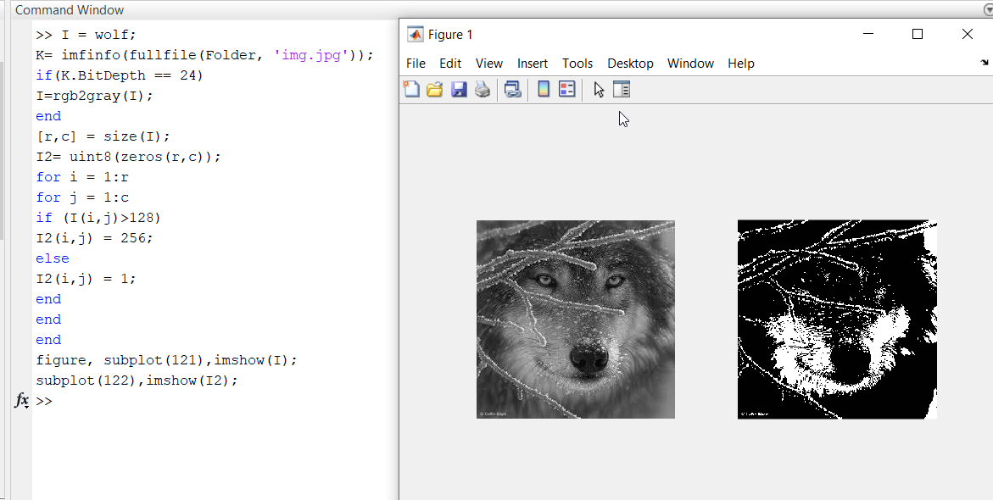

**Task 2** Zooming and Shrinking Images by Nearest Neighbor Write a computer program capable of zooming and shrinking an image by nearest neighbor algorithm. Assume that the desired zoom/shrink factors are integers. You may ignore aliasing effects.

**Zooming (original image is 2×2 image)**

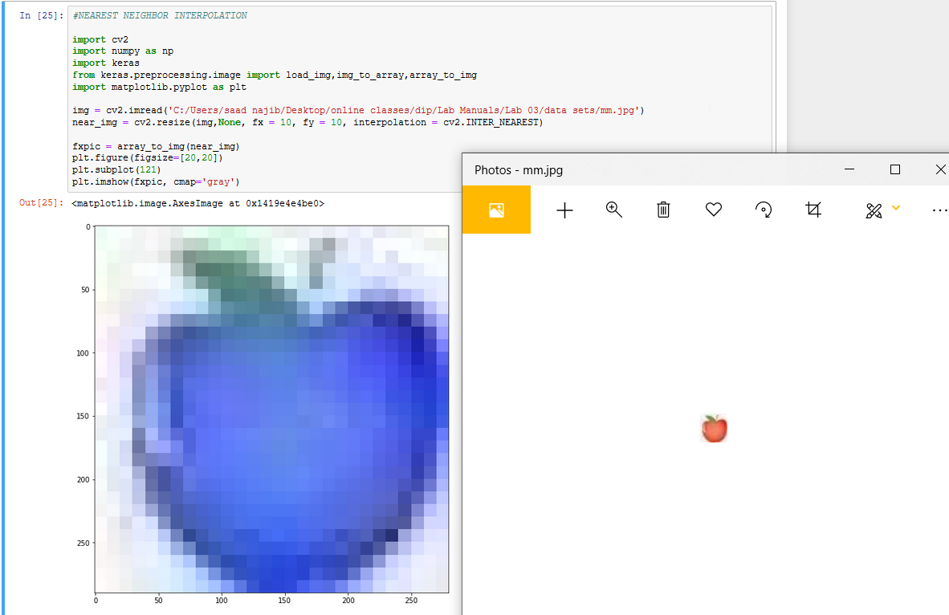

**Shrinking**

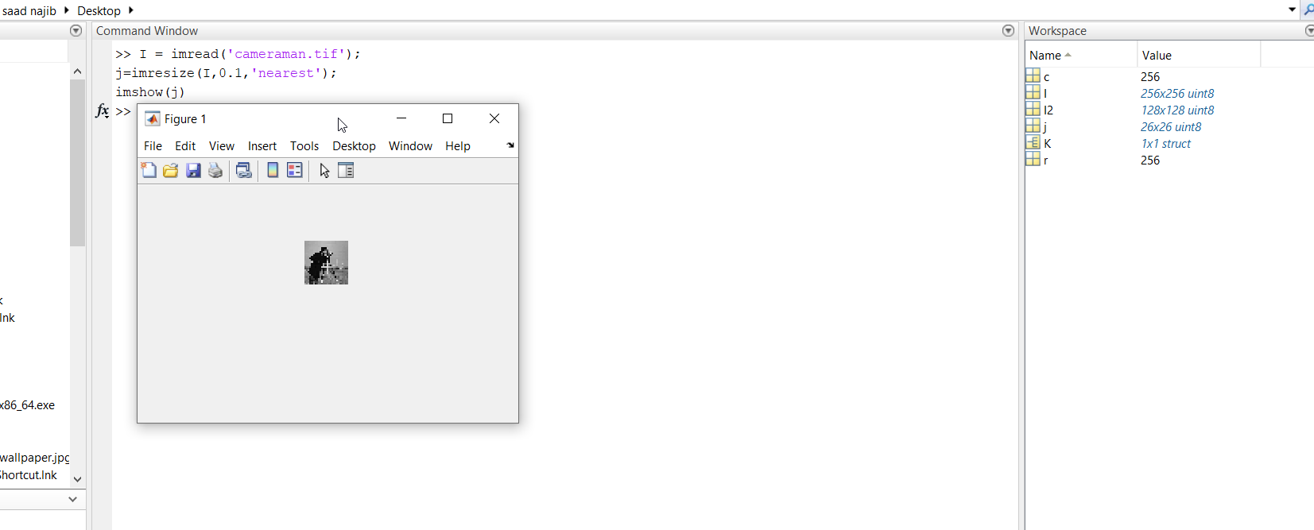

**Task 3** Zooming and Shrinking Images by Bilinear Interpolation Write a computer program capable of zooming and shrinking an image by bilinear interpolation. The input to your program is the desired size of the resulting image in the horizontal and vertical direction. You may ignore aliasing effects.

**Zooming**

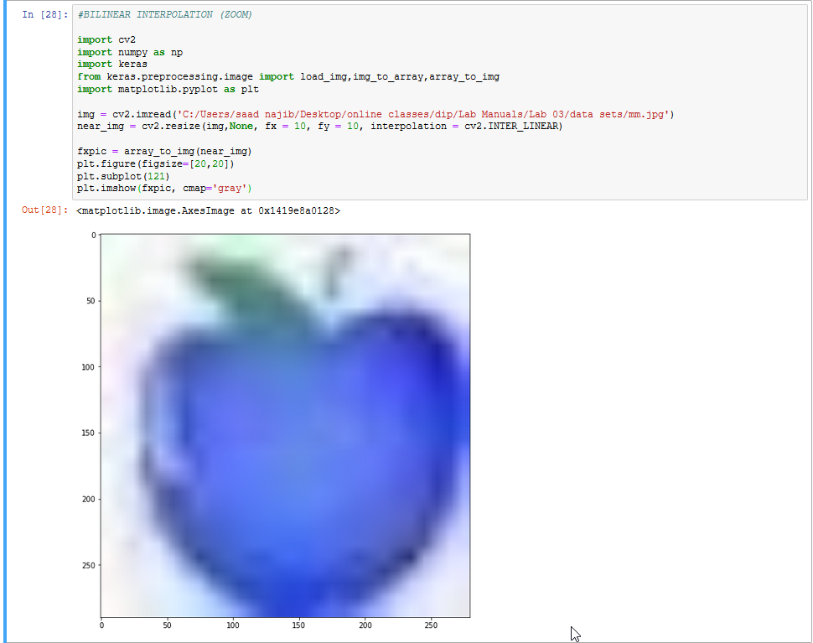

**Shrinking**

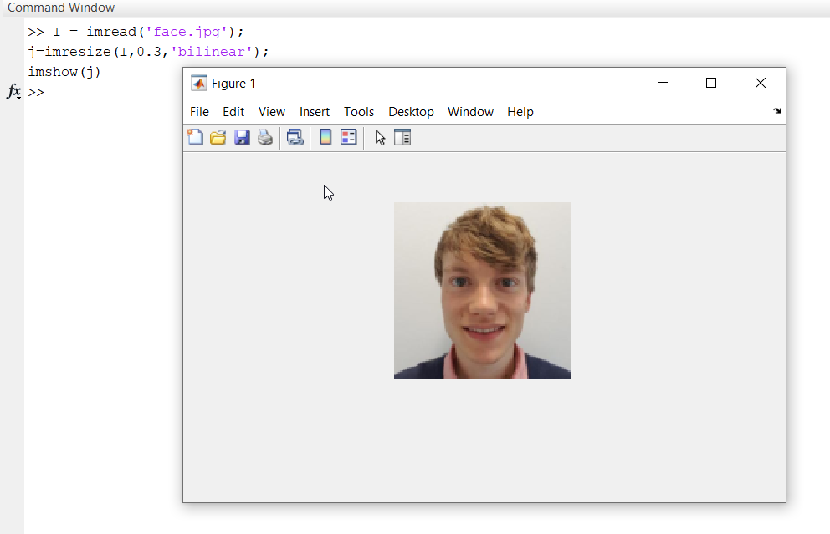

**Task 4** Implement the following transformation on your selected image and comment your observation:

**• Negation transform.**

Observation:

I observed that it totally removes the original color intensities form image.

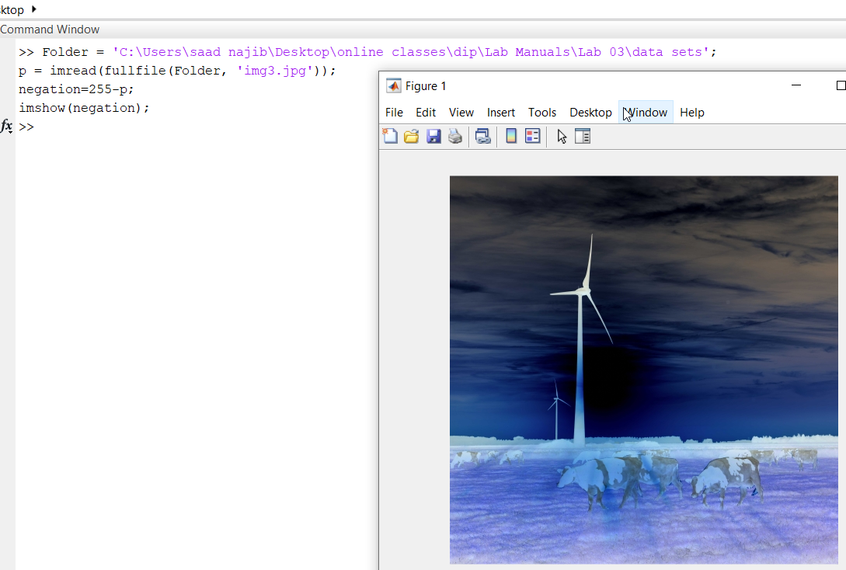

**• Logarithmic transform.**

Observation:

During log transformation, the dark pixels in an image are expanded as compare to the higher pixel values. The higher pixel values are kind of compressed in log transformation.

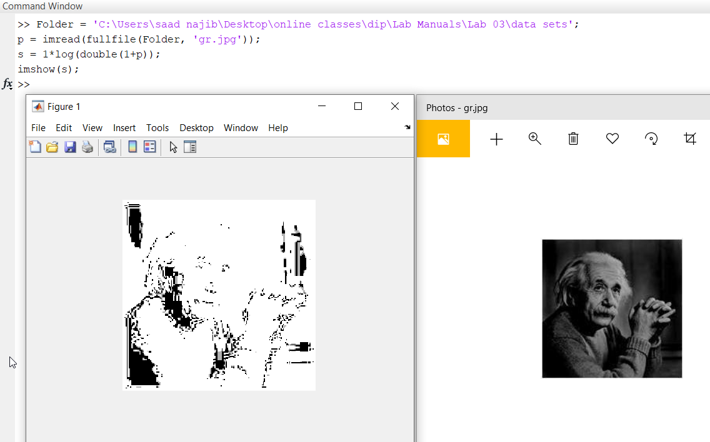

**• Power transform.**

Observation:

Variation in the value of γ varies the enhancement of the images, display image at different intensity.

